Project Design Phase
Solution Architecture

Date | 15 February 2026
Team ID | LTVIP2026TMIDS82253
Project Name | Deep Learning Fundus Image Analysis for Early Detection of Diabetic Retinopathy
Maximum Marks | 4 Marks

Solution Architecture
Solution architecture defines how the proposed system addresses the business problem of early detection of Diabetic Retinopathy (DR) by combining medical imaging, deep learning, and web technologies. It acts as a bridge between the healthcare problem and the technical implementation of the solution.
Objectives of the Solution Architecture
- Identify the most suitable technology stack to automate retinal image analysis.
- Clearly describe the system structure, components, and interactions for stakeholders such as doctors, developers, and administrators.
- Define functional features, development stages, and system requirements.
- Provide a scalable and manageable blueprint for implementation, deployment, and future enhancements.

Example - Solution Architecture Diagram:

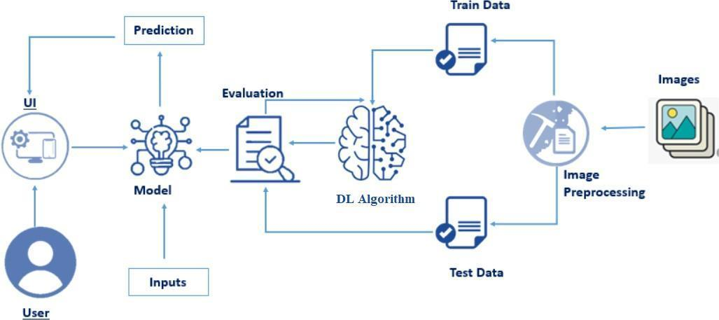
Figure 1: Architecture and data flow of the voice patient diary sample application

